Enclosure Concept
Base:
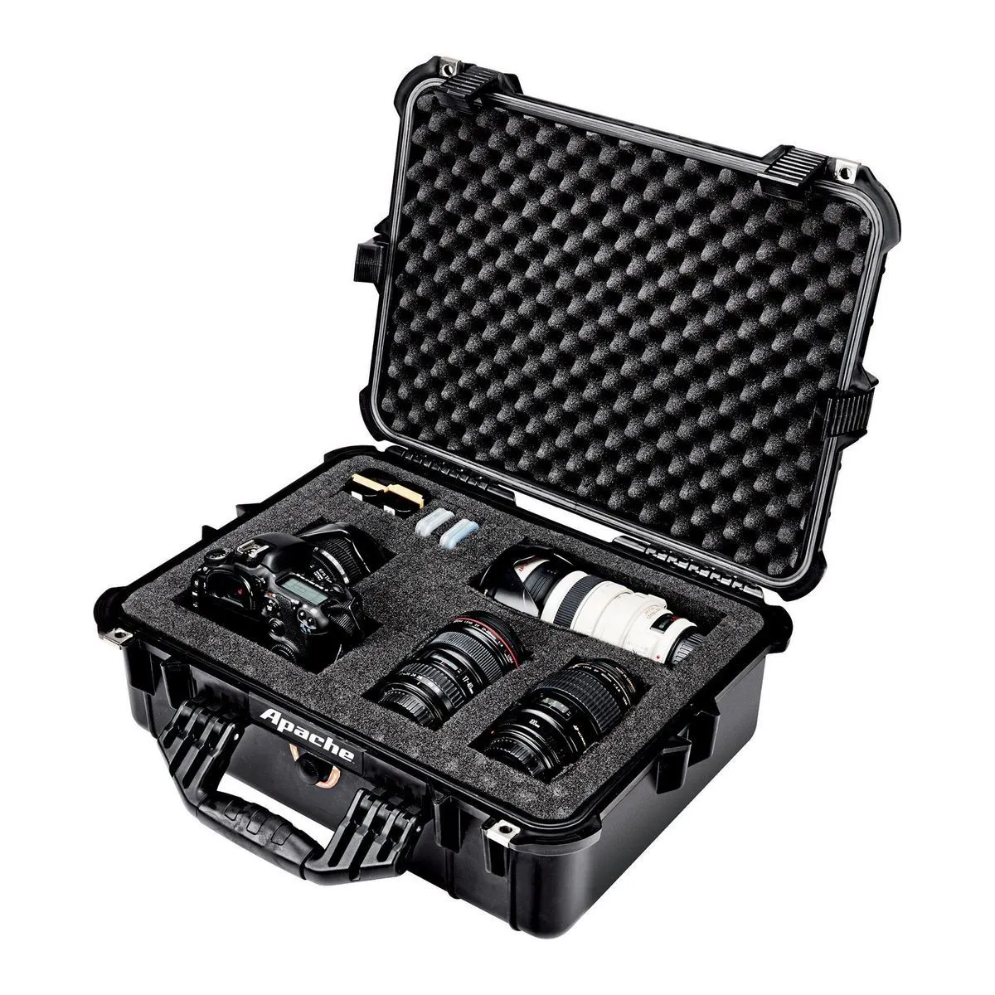(example)
- Plastic caring case
  - https://www.harborfreight.com/4800-weatherproof-protective-case-x-large-black-64250.html
- Large enough to hold electronics and devices (Max size 3”x 3”x 3”)
- Satisfies requirements:
  - Portable
  - Presentable
- Can be used to store any cables used in project

Inserts:
- 3D printed inserts
- Used to hold electronics in place and provide support to display
- I have access to my own printer as well as those in ISL lab and university makerspaces. It will likely be quicker and cheaper to use the personal one.

Other Considerations:
- Charging port on the side
  - While all devices need to have a battery life of at least one week, this port could be used to simultaneously charge all devices at once
  - Plastic case could be cut with combination of a drill and reciprocating saw

